**UNIT 1**

**INTRODUCTION TO CLOUD COMPUTING**

* 1. **Define cloud computing**

Cloud computing is a general term for the delivery of hosted services over the internet.

**Cloud computing is a type of computing that relies on sharing computing resources rather than having local servers or personal devices to handle applications.**

According to the National Institute of Standards and Technology definition of "cloud computing is a model for enabling ubiquitous, convenient, on-demand network access to a shared pool of configurable computing resources (e.g., networks, servers, storage, applications and services) that can be rapidly provisioned and released with minimal management effort or service provider interaction."

The definition includes the five essential characteristics of cloud computing:

1. **On-demand self-service:** A consumer can unilaterally provision computing capabilities, such as server time and network storage, as needed automatically without requiring human interaction with each service provider.
2. **Broad network access:** Capabilities are available over the network and accessed through standard mechanisms that promote use by heterogeneous thin or thick client platforms (e.g., [mobile](http://www.govinfosecurity.com/mobility-c-212) phones, tablets, laptops and workstations).
3. **Resource pooling:** The provider's computing resources are pooled to serve multiple consumers using a multi-tenant model, with different physical and virtual resources dynamically assigned and reassigned according to consumer demand. There is a sense of location independence in that the customer generally has no control or knowledge over the exact location of the provided resources but may be able to specify location at a higher level of abstraction (e.g., country, state or datacenter). Examples of resources include storage, processing, memory and network bandwidth.
4. **Rapid elasticity:** Capabilities can be elastically provisioned and released, in some cases automatically, to scale rapidly outward and inward commensurate with demand. To the consumer, the capabilities available for provisioning often appear to be unlimited and can be appropriated in any quantity at any time.
5. **Measured service:** Cloud systems automatically control and optimize resource use by leveraging a metering capability at some level of abstraction appropriate to the type of service (e.g., storage, processing, bandwidth and active user accounts). Resource usage can be monitored, controlled and reported, providing transparency for the provider and consumer.

**Service Models:**

**Cloud Software as a Service (SaaS)**

The capability provided to the consumer is to use the provider’s applications running on a cloud infrastructure. The applications are accessible from various client devices through a thin client interface such as a web browser (e.g., web-based email). The consumer does not manage or control the underlying cloud infrastructure including network, servers, operating systems, storage, or even individual application capabilities, with the possible exception of limited user-specific application configuration settings.

**Cloud Platform as a Service (PaaS)**

The capability provided to the consumer is to deploy onto the cloud infrastructure consumer-created or acquired applications created using programming languages and tools supported by the provider. The consumer does not manage or control the underlying cloud infrastructure including network, servers, operating systems, or storage, but has control over the deployed applications and possibly application hosting environment configurations.

**Cloud Infrastructure as a Service (IaaS)**

The capability provided to the consumer is to provision processing, storage, networks, and other fundamental computing resources where the consumer is able to deploy and run arbitrary software, which can include operating systems and applications. The consumer does not manage or control the underlying cloud infrastructure but has control over operating systems, storage, deployed applications, and possibly limited control of select networking components (e.g., host firewalls).

**Deployment Models:**

**Private cloud**

The cloud infrastructure is operated solely for an organization. It may be managed by the organization or a third party and may exist on premise or off premise.

**Community cloud**

The cloud infrastructure is shared by several organizations and supports a specific community that has shared concerns (e.g., mission, security requirements, policy, and compliance considerations). It may be managed by the organizations or a third party and may exist on premise or off premise.

**Public cloud**

The cloud infrastructure is made available to the general public or a large industry group and is owned by an organization selling cloud services.

**Hybrid cloud**

The cloud infrastructure is a composition of two or more clouds (private, community, or public) that remain unique entities but are bound together by standardized or proprietary technology that enables data and application portability (e.g., cloud bursting for load-balancing between clouds).

* 1. **A Short History of Cloud Computing**

Cloud concepts have existed for many years.

**Cloud Computing was a gradual evolution that started in the 1950s with mainframe computing.**

Multiple users were capable of accessing a central computer through dumb terminals, whose only function was to provide access to the mainframe. Because of the costs to buy and maintain mainframe computers, it was not practical for an organization to buy and maintain one for every employee. Nor did the typical user need the large (at the time) storage capacity and processing power that a mainframe provided. Providing shared access to a single resource was the solution that made economic sense for this sophisticated piece of technology.

**After some time, around 1970, the concept of virtual machines (VMs) was created.**

Using virtualization software like VMware, it became possible to execute one or more operating systems simultaneously in an isolated environment. Complete computers (virtual) could be executed inside one physical hardware which in turn can run a completely different operating system.

The VM operating system took the 1950s’ shared access mainframe to the next level, permitting multiple distinct computing environments to reside on one physical environment. Virtualization came to drive the technology, and was an important catalyst in the communication and information evolution.

**In the 1990s, telecommunications companies started offering virtualized private network connections.**

Historically, telecommunications companies only offered single dedicated point–to-point data connections. The newly offered virtualized private network connections had the same service quality as their dedicated services at a reduced cost. Instead of building out physical infrastructure to allow for more users to have their own connections, telecommunications companies were now able to provide users with shared access to the same physical infrastructure.

The following list briefly explains the evolution of cloud computing:

• **Grid computing**: Solving large problems with parallel computing  
• **Utility computing**: Offering computing resources as a metered service  
• **SaaS**: Network-based subscriptions to applications  
• **Cloud computing**: Anytime, anywhere access to IT resources delivered dynamically as a service

* 1. **How does Cloud Computing Works**

To understand exactly how cloud computing works, consider that the cloud consists of layers -mainly the back end layers and the front end layers. The front layers are the parts users can see and interact with. When users access their profile on their respective Facebook account for example, they are using software running on the front end of the cloud. The back end consists of the hardware and the software architecture that delivers the data on the front end.

Clouds use a network layer to connect users’ end point devices, like computers or smart phones, to resources that are centralized in a data centre. Users can access the data centre via a company network or the internet or both. Clouds can also be accessed from any location, allowing mobile workers to access their business systems on demand.

Applications running on the cloud take advantage of the flexibility of the computing power available. The computers are set up to work together so that it appears as if the applications were running on one particular machine. This flexibility is a major advantage of cloud computing, allowing the user to use as much or as little of the cloud resources as they want at short notice, without any assigning any specific hardware for the job in advance.

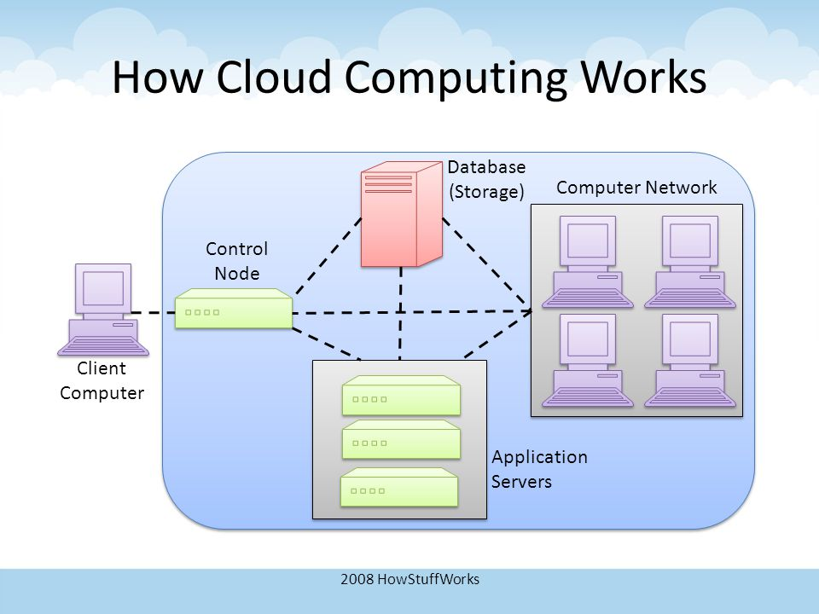

* 1. **Companies in the cloud today**

In just a few short years, cloud computing has become a tech that affects everyone's daily lives.

Our personal files are stored in the cloud. We maintain our friendships via apps in the cloud. Mobile phones and tablets run powerful apps via the cloud, giving rise to new devices like tablets, and killing off others, like the notebook and, perhaps one day, the PC.

IT departments went from distrusting the cloud to allocating billions of dollars to spend on using it. Instead of buying every app and server they need, they will rent them.

But none of this is happening on its own. It's all being figured out right now by the companies building clouds.

Amazon, Google, Microsoft, GoGrid, AT&T etc., are the companies working efficiently to provide unrelenting service to their customers.

* 1. **Why cloud computing matters**

For developers, cloud computing provides increased amounts of storage and processing power to run the applications they develop. Cloud computing also enables new ways to access information, process and analyze data, and connect people and resources from any location ssare no longer boxed in by physical constraints.

For IT departments, cloud computing offers more flexibility in computing power, often at lower costs. With cloud computing, IT departments don't have to engineer for peak-load capacity, because the peak load can be spread out among the external assets in the cloud. And, because additional cloud resources are always at the ready, companies no longer have to purchase assets (servers, workstations, and the like) for infrequent intensive computing tasks. If you need more processing power, it's always there in the cloud—and accessible on a cost-efficient basis.

For end users, cloud computing offers all these benefits and more. An individual using a web-based application isn't physically bound to a single PC, location, or network. His applications and documents can be accessed wherever he is, whenever he wants. Gone is the fear of losing data if a computer crashes. Documents hosted in the cloud always exist, no matter what happens to the user's machine.

And then there's the benefit of group collaboration, for both individuals and organizations. Users from around the world can collaborate on the same documents, applications, and projects, in real time. It's a whole new world of collaborative computing, all enabled by the notion of cloud computing.

For everyone concerned, cloud computing does all this at lower costs, because the cloud enables more efficient sharing of resources than does traditional network computing. When you tap into the power of the cloud, you get supercomputing power at PC prices—something that offers particular appeal to individuals and small businesses. And, with cloud computing, hardware doesn't have to be physically adjacent to a firm's office or data center; cloud infrastructure can be located anywhere, including and especially areas with lower real estate and electricity costs.

* 1. **Pros and cons of cloud computing**

**Advantages**

* **Worldwide Access**: Cloud computing increases mobility, as documents can be accessed from any device in any part of the world. For businesses, this means that employees can work from home or on business trips, without having to carry around documents. This increases productivity and allows faster exchange of information. Employees can also work on the same document without having to be in the same place.
* **More Storage**. In the past, memory was limited by the particular device in question. If one ran out of memory, one would need a USB drive to backup their current device. Cloud computing provides increased storage, so one won’t have to worry about running out of space on their hard drive.
* **Easy Set-Up**. It is very easy to set up a cloud computing service in a matter of minutes. Adjusting individual settings, such as choosing a password or selecting which devices want to connect to the network, is similarly simple. After that, one can immediately start using the resources, software, or information in question.
* **Automatic Updates**. The cloud computing provider is responsible for making sure that updates are available – user can just have to download them. This saves the time, and furthermore, users need not to be an expert to update the device; the cloud computing provider will automatically notify and provide with instructions.
* **Reduced Cost**. Cloud computing is often inexpensive. The software is already installed online. There are numerous cloud computing applications available for free, and increasing storage size and memory is affordable. If one needs to pay for a cloud computing service, it is paid for incrementally on a monthly or yearly basis. By choosing a plan that has no contract, one can terminate their use of the services at any time; therefore, users can only pay for the services when they need them.

## Disadvantages

* **Security**. When using a cloud computing service, stakeholders are essentially handing over the data to a third party. The fact that the entity, as well as users from all over the world, is accessing the same server can cause a security issue. Companies handling confidential information might be particularly concerned about using cloud computing, as data could possibly be harmed by viruses and other malware. That said, some servers like Google Cloud Connect come with customizable spam filtering, email encryption, and SSL enforcement for secure HTTPS access, among other security measures.
* **Privacy**. Cloud computing comes with the risk that unauthorized users might access the information. To protect against this happening, cloud computing services offer password protection and operate on secure servers with data encryption technology.
* **Loss of Control**. Cloud computing entities control the users. This includes not only how much users have to pay to use the service, but also what information can store, where one can access it from, and many other factors. It totally depends on the provider for updates and backups. If for some reason, their server ceases to operate, there may be the risk of losing all user information.
* **Internet Reliance**. While Internet access is increasingly widespread, it is not available everywhere just yet. If the area that user is in doesn’t have Internet access, there won’t be able to open any of the documents stored by user in the cloud.
  1. **Benefits of cloud computing**

## 1. Flexibility

Cloud-based services are ideal for businesses with growing or fluctuating bandwidth demands. If business needs increase it’s easy to scale up the cloud capacity, drawing on the service’s remote servers. Likewise, if need to be scaled down again, the flexibility is baked into the service. This level of agility can give businesses using cloud computing a real advantage over competitors.

## 2. Disaster recovery

Businesses of all sizes should be investing in robust disaster recovery, but for smaller businesses that lack the required cash and expertise; this is often more an ideal than the reality. Cloud is now helping more organizations buck that trend, that save time, avoid large up-front investment and roll up third-party expertise as part of the deal.

## 3. Automatic software updates

The beauty of cloud computing is that the servers are off-premise, out of sight and out of the hair. Suppliers take care of them for end user and roll out regular software updates – including security updates – so consumers don’t have to worry about wasting time maintaining the system themselves. Leaving free to focus on the things that matter, like growing your business

## 4. Capital-expenditure Free

Cloud computing cuts out the high cost of hardware. It is simply pay as you go and enjoys a subscription-based model that’s kind to the cash flow.

## 5. Increased collaboration

When teams of the business can access, edit and share documents anytime, from anywhere, they’re able to do more together, and do it better. Cloud-based workflow and file sharing apps help them make updates in real time and gives them full visibility of their collaborations.

## 6. Work from anywhere

With cloud computing, if users have got an internet connection they can be at work. And with most serious cloud services offering mobile apps, users are not restricted by which device they have got to hand.

## 7. Document control

The more employees and partners collaborate on documents, the greater the need for watertight document control. Before the cloud, workers had to send files back and forth as email attachments to be worked on by one user at a time.

When once make the move to cloud computing, all files are stored centrally and everyone sees one version of the truth. Greater visibility means improved collaboration, which ultimately means better work and a healthier bottom line.

## 8. Security

Lost laptops are a billion dollar business problem. And potentially greater than the loss of an expensive piece of kit is the loss of the sensitive data inside it. Cloud computing gives greater security when this happens. Because the data is stored in the cloud, one can access it no matter what happens to their machine. And one can even remotely wipe data from lost laptops so it doesn’t get into the wrong hands.

* 1. **Who shouldn't be using cloud computing**

Now let’s look at the flip side of the coin. If cloud computing isn’t for everyone, who isn’t it for?

### The Internet-Impaired

Because cloud computing is based on the Internet cloud and depends on Internet access, if you don’t have Internet access, you’re out of luck. Without Internet access, you can’t run web-based applications or open documents stored on the web. Users without readily available Internet access simply shouldn’t be considering a switch to cloud-based computing—until they get Internet access, that is.

The same goes if you have slow Internet access, like that found with dial-up Internet connections. A slow connection isn’t much better than none at all when accessing big apps and docs on the web. It takes a long time to download these apps and docs, and that waiting time becomes intolerable on anything less than a broadband connection.

### Offline Workers

Along the same lines, anyone who consistently works offline in a non-Internet-enabled environment probably isn’t the ideal candidate for cloud computing. That means anyone who works out of their vehicle, anyone who works in an office without Internet access, anyone who works at home without Internet access, and anyone who travels from office to office without guarantee of an Internet connection. No Internet, no cloud computing—it’s that simple.

### The Security Conscious

Today, we think that cloud computing is safe—but we can’t guarantee that. It’s certainly possible that cloud systems can be hacked and cloud-based documents accessed by unauthorized users; it’s also possible that your data could be snagged during transmission between your computer and the cloud. It may be unlikely, but it can happen.

If your documents are confidential, you probably don’t want to trust them with cloud computing just yet. Just as you wouldn’t transmit confidential documents over a public Wi-Fi network, you shouldn’t upload and store your documents on a cloud computing network with questionable security. When security matters, don’t take chances.